R plot pch symbols, In this tutorial we are going to describe different pch values in R. The plotting argument used to specify point shapes is **pch**.

Let’s install the ggpubr package from cran, and then plot different shapes in R.

#install.packages("ggpubr") ggpubr::show_point_shapes()

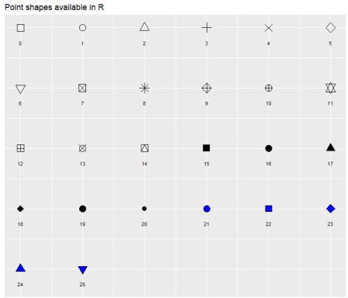

R Plot pch Symbols

The 25 different points symbols are commonly used in R for making beautiful graphs.

pch = 0,square pch = 1,circle

pch = 2,triangle point up pch = 3,plus

pch = 4,cross pch = 5,diamond

pch = 6,triangle point down pch = 7,square cross

pch = 8,star

pch = 9,diamond plus pch = 10,circle plus

pch = 11,triangles up and down pch = 12,square plus

pch = 13,circle cross

pch = 14,square and triangle down pch = 15, filled square

pch = 16, filled circle

pch = 17, filled triangle point-up pch = 18, filled diamond

pch = 19, solid circle

pch = 20,bullet (smaller circle) pch = 21, filled circle blue

pch = 22, filled square blue pch = 23, filled diamond blue

pch = 24, filled triangle point-up blue pch = 25, filled triangle point down blue

Let create a default plot pch = 1 (empty circle)

plot(x = mtcars$mpg, y = mtcars$disp, frame = FALSE, xlab = "MPG", ylab = "DISP")

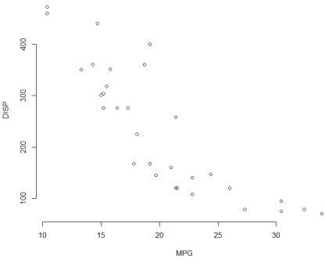

As mentioned above, we can change different pch values.

Change plot symbol to pch = 8 (star)

plot(x = mtcars$mpg, y = mtcars$disp, frame = FALSE, xlab = "MPG", ylab = "DISP",

pch = 8)

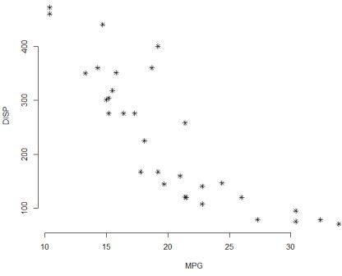If you want to change the color and the size of points, use the following arguments

col: For example, col = “red” or col = “#FF0000”.

cex: the size of point symbols. Numeric values, 1=default, 1.5 is 50% larger, 0.5 is 50% smaller, etc.

For making attractive plots you can make use of bg and lwd arguments also.

bg: plot background color

lwd: ine width relative to the default (default=1). 2 is twice as wide If you want to know more about lwd check it here

**Change color and background**

plot(x = mtcars$mpg, y = mtcars$disp, frame = FALSE, xlab = "MPG", ylab = "DISP",

pch = 8, col = "#FF0000")

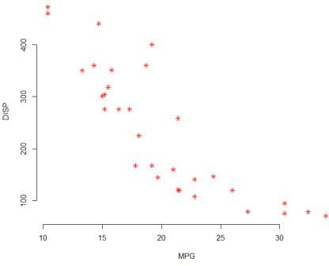Use pch = 21 and change border line width (lwd), and background color (bg)

plot(x = mtcars$mpg, y = mtcars$disp, frame = FALSE, xlab = "MPG", ylab = "DISP",

pch = 21, bg = "red", col = "black", lwd = 0.9, cex = 1.5)

